Watermelon and Arugula Salad

* [Nutrition](http://www.teambeachbody.com/teambeachbodyblog/category/nutrition)

* [Recipes](http://www.teambeachbody.com/teambeachbodyblog/category/nutrition/recipes)

May 19, 2015

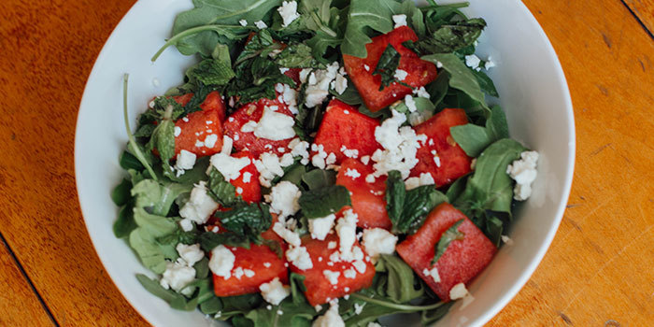

Salads don’t have to include a lot of ingredients to taste phenomenal. This [21 Day Fix](http://www.beachbody.com/product/fitness_programs/21-day-fix-simple-fitness-eating.do?ICID=BLOG_BB_21DF)-inspired recipe has only 4 ingredients that work perfectly together. Peppery arugula is topped with juicy watermelon and fresh mint leaves. A sprinkling of feta cheese is the finishing touch. This salad takes just a few minutes to make, so even people with busy schedules can find time to eat a healthy meal. A drizzle of good balsamic vinegar is all the dressing you need.

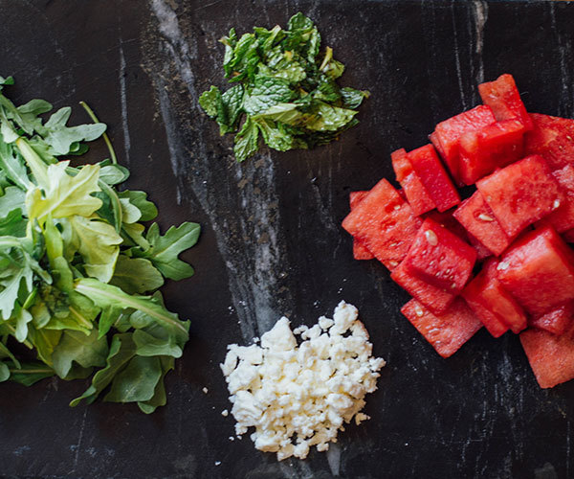

**For those following the 21 Day Fix Eating Plan, this salad uses 1 green, ½ purple, and ½ blue container.**

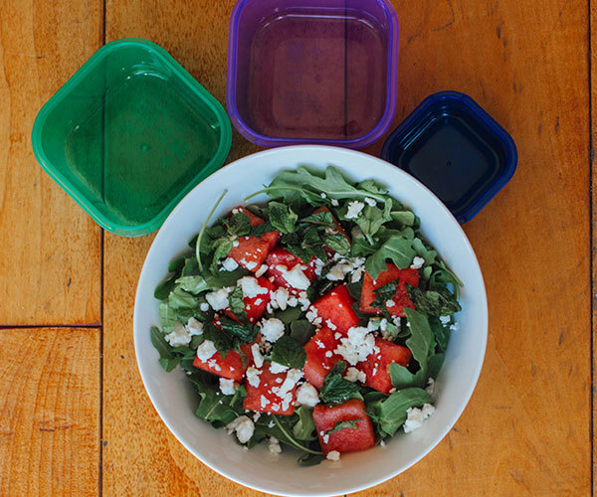

**Watermelon and Arugula Salad**

**Total Time:** 15 min.  
**Prep Time:** 15 min.  
**Cooking Time:** None  
**Yield:** 1 serving

**Ingredients:**  
2 cups fresh arugula  
1 cup cubed watermelon  
2 Tbsp. crumbled feta cheese  
10 coarsely chopped fresh mint leaves

**Preparation:**  
1. Place arugula on a serving plate.  
2. Top with watermelon, cheese, and mint.  
3. Top with your favorite dressing and enjoy!

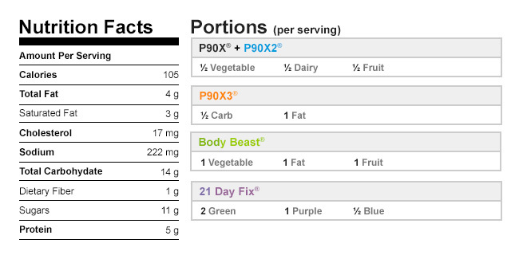

Authors

[Beachbody](http://www.teambeachbody.com/teambeachbodyblog/author/beachbody)

Tags[5 ingredients or less](http://www.teambeachbody.com/teambeachbodyblog/tag/5-ingredients-or-less),[dinners](http://www.teambeachbody.com/teambeachbodyblog/tag/dinners), [lunches](http://www.teambeachbody.com/teambeachbodyblog/tag/lunches), [recipes](http://www.teambeachbody.com/teambeachbodyblog/tag/recipe),[salads](http://www.teambeachbody.com/teambeachbodyblog/tag/salads), [side dishes](http://www.teambeachbody.com/teambeachbodyblog/tag/side-dishes),[vegetarian](http://www.teambeachbody.com/teambeachbodyblog/tag/vegetarian)

RELATED POSTS